4. Binary Search with Big-O Analysis

Aim
To implement the Binary Search algorithm using Python and analyze its Big-O time complexity.

Algorithm
- Start.
- Create a sorted array.
- Set low to the first index and high to the last index.
- Calculate the middle index.
- Compare the middle element with the search element.
- If they are equal, display the position.
- If the search element is greater, search the right half.
- If the search element is smaller, search the left half.
- Repeat until the element is found or the search range becomes empty.
- Stop.

Procedure
- Open Python IDLE, VS Code, or an online Python compiler.
- Create a sorted array.
- Enter the element to be searched.
- Initialize low and high.
- Calculate the middle position using (low + high) // 2.
- Compare the middle element with the search element.
- Reduce the search area to either the left or right half.
- Continue until the element is found or the search ends.
- Display the result.
- Analyze the time complexity as O(log n).
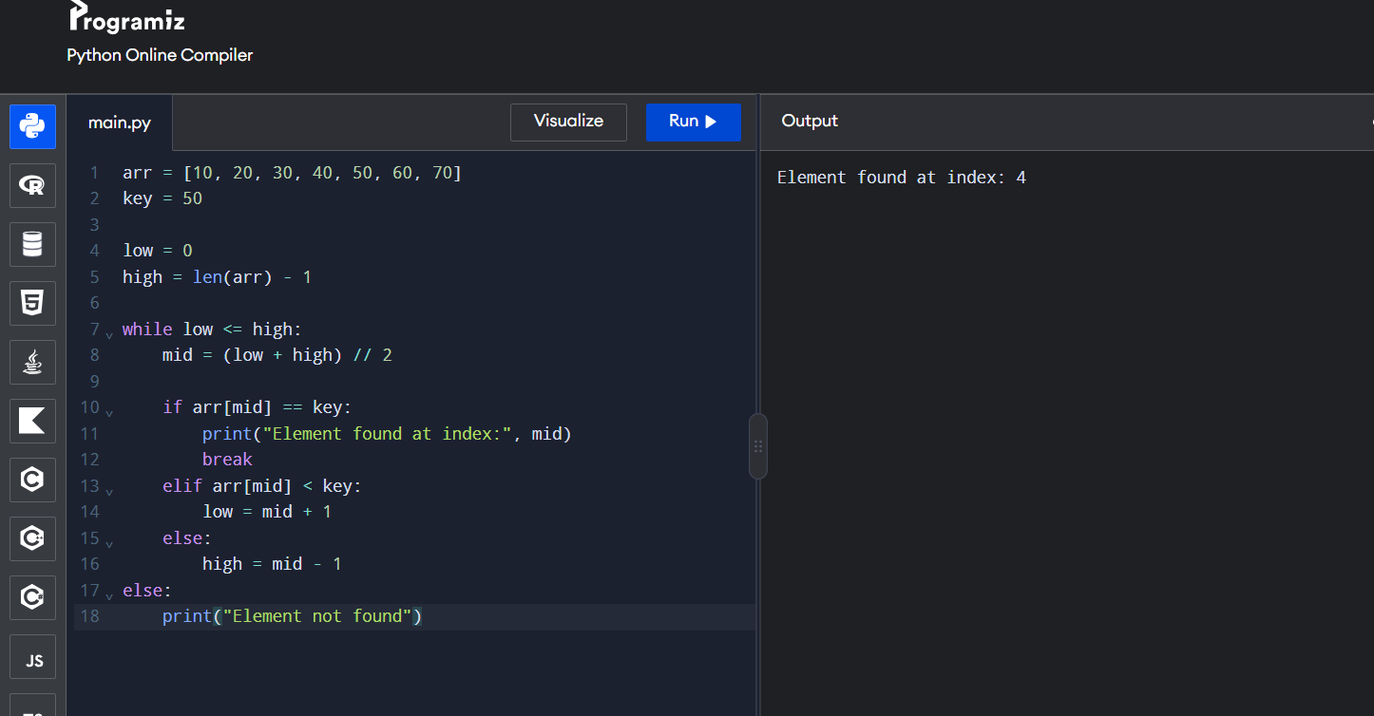

Result:

Thus, the Python program successfully searches for an element using Binary Search. The worst-case time complexity is O(log n).

